**Implement view in hive by following the steps in the below blog**

Have a created a view named realestate_view by selecting the data from realestate table

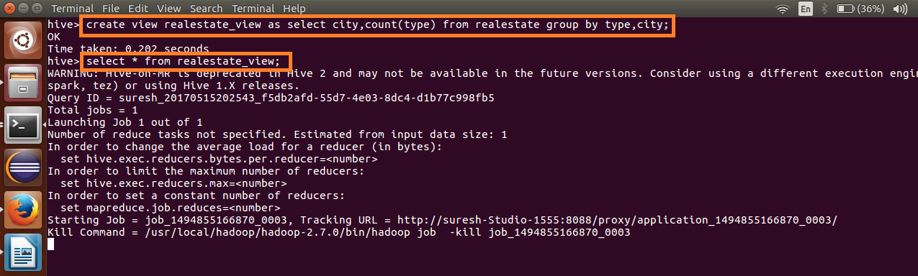

Output:

